Data modification 1:

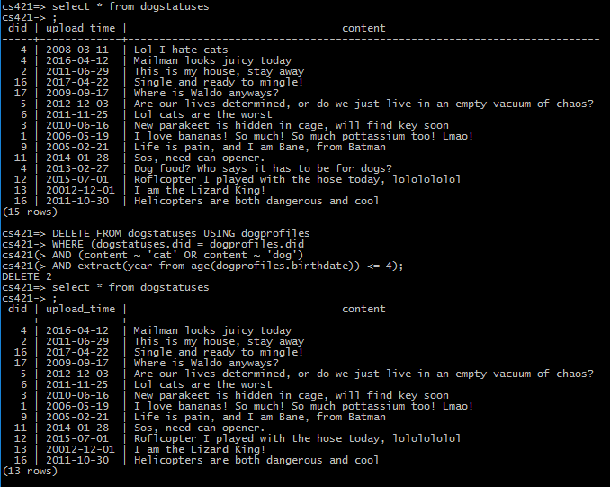

Data modification 2:

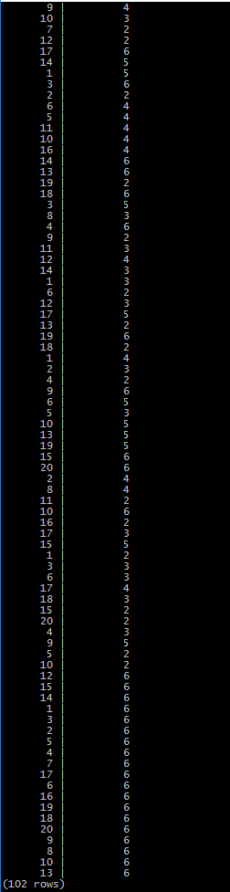

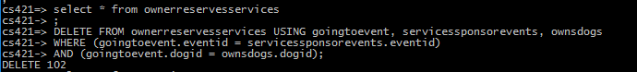

Data modification 3: comparing the left to the right, we can see that all 1s have been removed in the right column

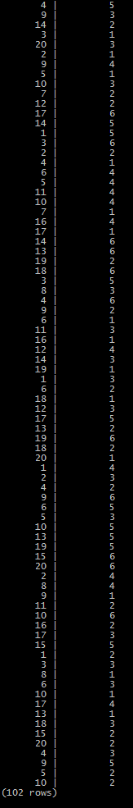

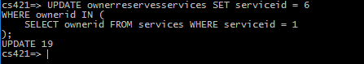

Data modification 4: we can see that 30 owners have been added to club 8

